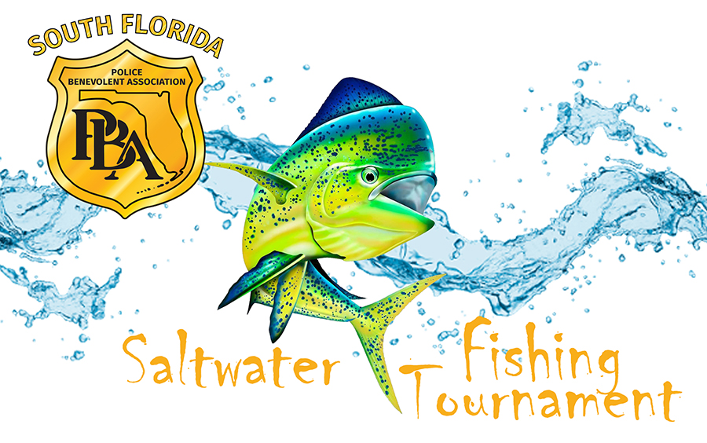

REGISTRATION FORM
Tournament date, Saturday, June 7, 2025
Final registration is at the mandatory Captain’s Meeting on Thursday, June 5, 2025 at 6:30 p.m., at the PBA, located at 10680 NW 25 Street, Doral FL. Tournament starts at 6:00 a.m. from any port. Weigh-in will be from 1:00 p.m. to 4:00 p.m. at Matheson Hammock Park Marina, at the police office / fuel dock. You must be at the docks/in line by 4:00 p.m., to weigh- in. Awards Ceremony will occur after the last weigh-in.

Captain: ____________________________________________________________________________________

Address: ___________________________________________________________________________________

Cell Phone ____________________________________ Business Phone _____________________________

E-mail Address_________________________________ Team Name ________________________________

Boat Description (Name, Make, Length, Registration #): _______________________________________

____________________________________________________________________________________________

Team Members | PBA Member? | T-Shirt Size

TOTAL FEE:

Official PBA Fishing Tournament Rules:
1. No spear fishing.
2. No limitations on types of fishing equipment (i.e. rods, reels or lb. test line)
3. Final registration will be at the Captain's meeting -- NO EXCEPTIONS.
4. Weigh-in is from 1:00 p.m. – 4:00 p.m. -- NO EXCEPTIONS.
5. In case of a tie, first fish in and weighed wins its division.
6. Tournament will conform to all State and Federal laws.
7. Fishing license mandatory for each participant.
8. Fish may be brought in by boat or car. One fish can only qualify under one category.
9. Jr. Division 15 and under.
9. All decisions by judges are final.

Classification Prizes:
1. First Heaviest Dolphin: $2,000 plus Trophy 6. “Fun Fish”: Trophy only
2. Second Heaviest Dolphin: $1,000 plus Trophy 7. *Jr. Division 1st Place: $100 plus Trophy
3. Third Heaviest Dolphin: $500 plus Trophy 8. *Jr. Division 2nd Place: $75 plus Trophy
4. Best of Three Dolphin: $300 plus Trophy 9. *Jr. Division 3rd Place: $50 plus Trophy
5. Heaviest Dolphin Female Angler: $500 *One award per angler
An extra $1,000 for the PBA member with the Heaviest Dolphin

